Vertical Translations of Linear Functions Name________________________Period_____
The Rule for Vertical Translations:
A linear function has a graph that is a straight line. The simplest linear function is f(x) = x. The graph is a line that has a y-intercept (the point at which the y-axis and the graph intersect) at the origin (0,0) and has a slope of 1. In slope-intercept form, the function would be f(x) = 1x + 0.
All other linear functions can be created by using a transformation (translation, reflection, and stretching) on the parent function f(x) = x. The notation for transformation is to rename the function after the transformation and then tell how the transformation happened. For example, g(x) = f(x) + 1 means the function f(x) moves up one spot and becomes the function named g(x).
If y = f(x), then y = f(x) + k gives a vertical translation. The translation k moves the graph upward when k is a postive value and downward when k is negative value.
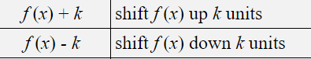

What Is Translation?

When translating a function f(x), you can move the function vertically along the y-axis. A translation that moves a function vertically is denoted outside of the function notation. For example, the translation f(x) + 3 will move the function up three places. A vertical change moves according to the directions. A vertical change of f(x) + 7 moves the function f(x) up seven places.

Example
Let's take a look at an example of translation:
Translate the function f(x) = 4x - 7 five places down to create g(x).
The new function will look like:
- g(x) = 4x – 12
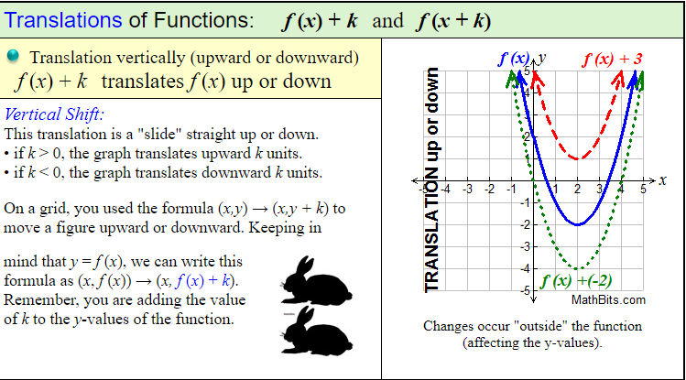
Practice:
1. | F(x) = x + 3  Translate f(x) down 5 units. Write the transformed function in terms of g(x) and then graph both on the right.
2. | f(x) = 4x ‐ 3  Translate the graph 2 up. Write the transformed function in terms of g(x) and then graph both on the right
3. | f(x) = 2x – 3  Tranlate f(x) down 2 units. Write the transformed function in terms of g(x) and then graph both on the right.
4. | Let f(x) = 3x – 2.  Use the given function to describe the listed transformations. Then, write the equation p(x) of the transformed function.  - f(x) – 7 _______________________________________  - f(x) + 8 _______________________________________  - F(x) + 1 _______________________________________
5. | 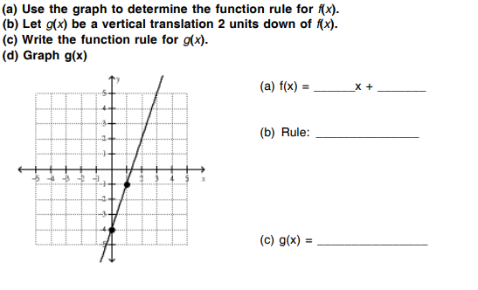
6. | 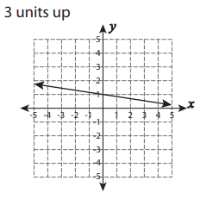
7. | 