Triangle Congruence Theorems Name_________________________Period____________
(SSS, SAS, & ASA Postulates)
Triangles can be similar or congruent. Similar triangles will have congruent angles but sides of different lengths. Congruent triangles will have completely matching angles and sides. Their interior angles and sides will be congruent. Testing to see if triangles are congruent involves three postulates, abbreviated SAS, ASA, and SSS.
Congruence Definition: Two triangles are congruent if their corresponding sides are equal in length and their corresponding interior angles are equal in measure.
We use the symbol ≅ to show congruence.
Corresponding sides and angles mean that the side on one triangle and the side on the other triangle, in the same position, match. You may have to rotate one triangle, to make a careful comparison and find corresponding parts.
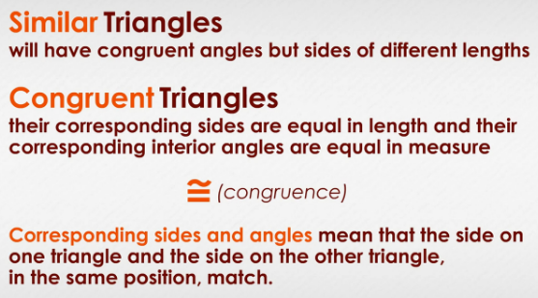
Postulate Definition: A postulate is a statement presented mathematically that is assumed to be true. All three triangle congruence statements are generally regarded in the mathematics world as postulates, but some authorities identify them as theorems (able to be proved).
ASA Theorem (Angle-Side-Angle)
The Angle Side Angle Postulate (ASA) says triangles are congruent if any two angles and their included side are equal in the triangles. An included side is the side between two angles. | In the sketch below, we have △CAT and △BUG. Notice that ∠C on △CAT is congruent to ∠B∠B on △BUG, and ∠A on △CAT is congruent to ∠U on △BUG.
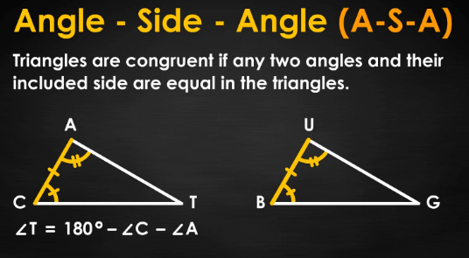
You may think we rigged this, because we forced you to look at particular angles. The postulate says you can pick any two angles and their included side. So go ahead; look at either ∠C and ∠T or ∠A and ∠T on △CAT. | Compare them to the corresponding angles on △BUG. You will see that all the angles and all the sides are congruent in the two triangles, no matter which ones you pick to compare.

SAS Theorem (Side-Angle-Side)
By applying the Side Angle Side Postulate (SAS), you can also be sure your two triangles are congruent. Here, instead of picking two angles, we pick a side and its corresponding side on two triangles. | The SAS Postulate says that triangles are congruent if any pair of corresponding sides and their included angle are congruent.
Pick any side of △JOB below. Notice we are not forcing you to pick a particular side, because we know this works no matter where you start. Move to the next side (in whichever direction you want to move), which will sweep up an included angle. | 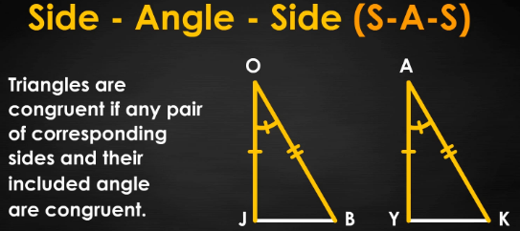
For the two triangles to be congruent, those three parts -- a side, included angle, and adjacent side -- must be congruent to the same three parts -- the corresponding side, angle and side -- on the other triangle, △YAK.
SSS Theorem (Side-Side-Side Theorem)
Perhaps the easiest of the three postulates, Side Side Side Postulate (SSS) says triangles are congruent if three sides of one triangle are congruent to the corresponding sides of the other triangle. |  | 