Solving Linear Equations Notes and Practice Name________________________________
Bellwork:
- 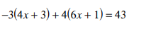 2. 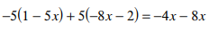

ACT Question: New one on board every day. This is example of first one and the website I get it from.
http://sbstjohn.com/QODWebSite/PreElemAlg/alg_f036.htm
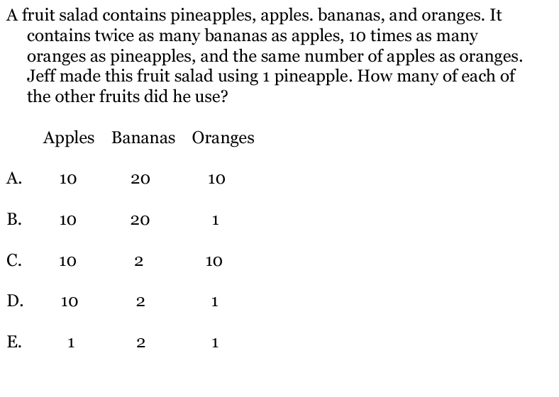
Remember: Solving a linear equation is a process of undoing operations that have been applied to the variable when the equation was created. Your goal is to isolate the variable on one side of the equal sign.
Remember: You must always make the same changes to BOTH sides of the equal sign to "balance the equation".
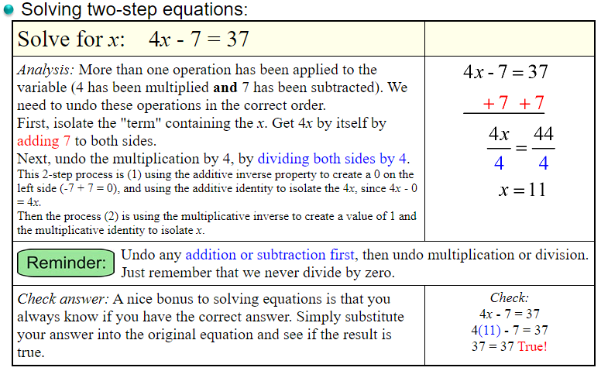
Practice:
- 26 = 8 + 9v | - -15 + 2n = -9 | - -4m – 9 = -13
- -6 = $\frac{4b}{18}$ | - 16 = $\frac{4k}{11}$ | - -126 = 2k + 8
- -17 = -2x – 15 | - 3a + 11 = -20 | - 18 + -5m = 8

A linear equation can have one solution, no solution, or infinite solutions. The previous example was a linear equation with one solution.
A linear equation with no solution means that there is no value for the variable that makes the equation true. This is when the variable disappears and you are left with a FALSE statement. (ex. 3=7)
A linear equation with infinite solutions means that any value for the variable makes the equation true. This is when the variable disappears and you are left with a TRUE statement. (ex. 12=12)
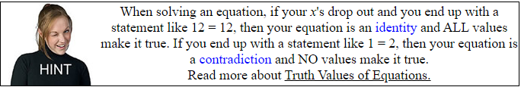
Practice:
- 4m - 4 = 4m 2. -9 + 4r = 4r – 3 - 6

3 24a - 22 = -4(1 - 6a) 4. 3 = 3(x – 5) – 3(x – 6)

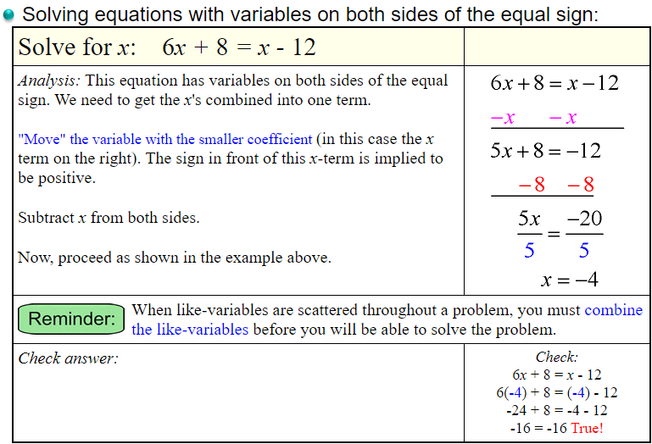
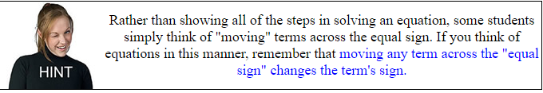
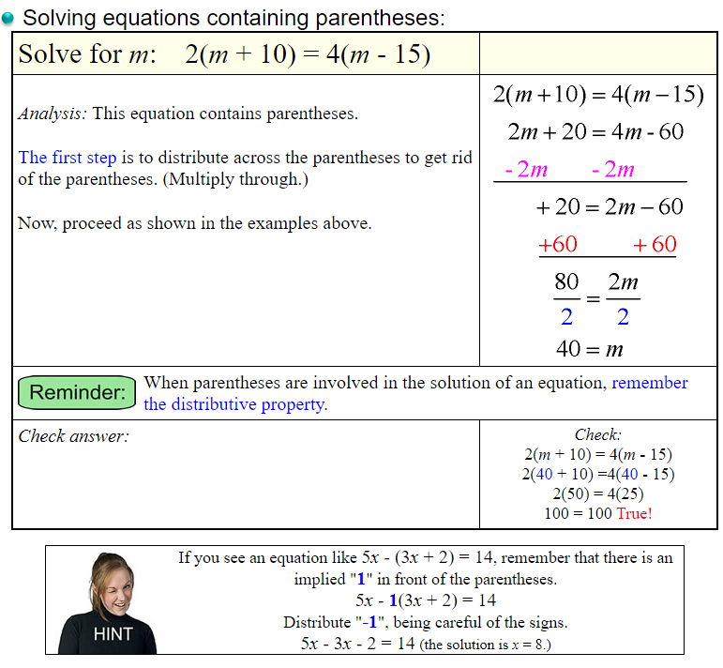
Practice Solving with variables on both Sides and parentheses:
1. | −10 + x + 4 − 5 = 7x − 5 | 2. | 4n − 40 = 7(−2n + 2)
3. | −31 − 4x = −5 − 5(1 + 5x) | 4. | 38 + 7k = 8(k + 4)
5. | 8x + 4(4x − 3) = 4(6x + 4) − 4 | 6. | 4(−8x + 5) = −32x − 26
7. | −7x − 3x + 2 = −8x − 8 | 8. | −14 + 6b + 7 − 2b = 1 + 5b

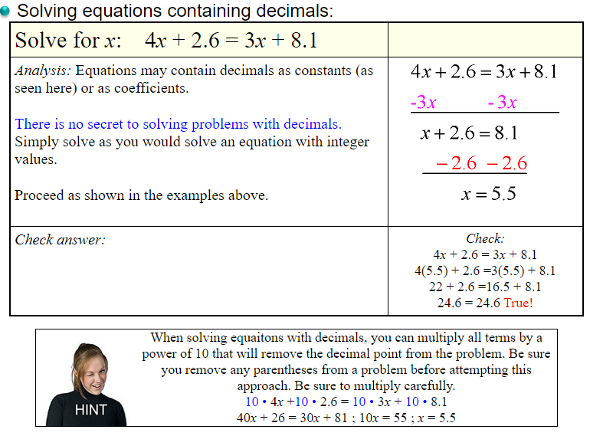
Practice solving equations with decimals:.
1. | 0.72 = 0.4(x + 1.4) | 2. | 0.6v + 1.3v = 3.04
3. | −4.84 = −1.3k + 2.7 | 4. | −2.4 = 2.4k + 1.6k
5. | −0.5x − 3.69 = x − 1.9 − 2.39 | 6. | 2.1(2.3 + 2.1x) = 11.65 + x
Justify Steps to Linear Equations:
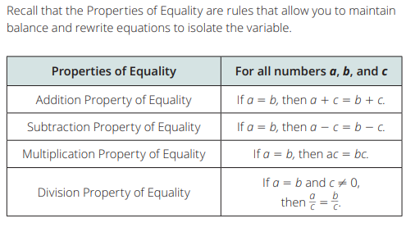
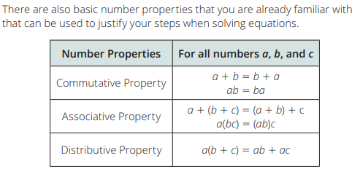
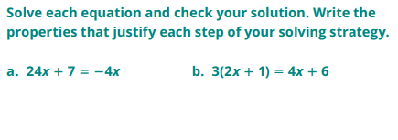

Practice Justification Steps:
