Poland; Notes and Practice Name___________________________________________Period______
Module 1:Topic 3: Linear Regressions (Lesson 1-Least Squares Regression)
Bell Work: Find and write an inequality showing the Domain and Range of this Function.
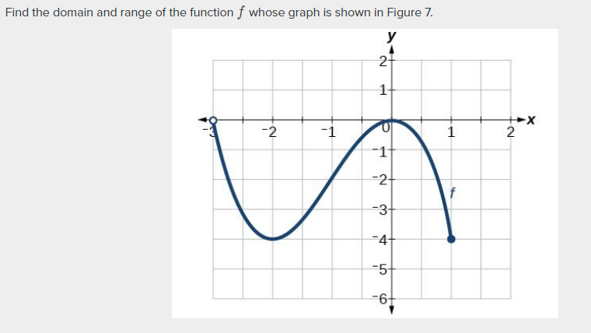 | Domain:__________________  Range__________________

Module 1; Topic 3; Linear Regressions
Learning Goals:
“I CAN”:
- Create a graph of data points with and without technology.
- Determine an equation for a line of best fit by visual approximation of a hand-drawn line.
- Determine a linear regression equation using technology.
- Make predictions about data using linear regression equation.
- Explain the calculations involved in the Least Squares Method.
- Choose a level of accuracy appropriate when reporting quantities.
Where have we been?
You have searched for patterns in graphs and sequence of numbers. You can identify function families based on certain characteristics! How can you use what you know to identify patterns in sets of data? (What patterns do you look for and what do they tell you?)
F(x) = mx + b Formulas that could help
M = y2-y1 you in finding line of best fit
x2-x1
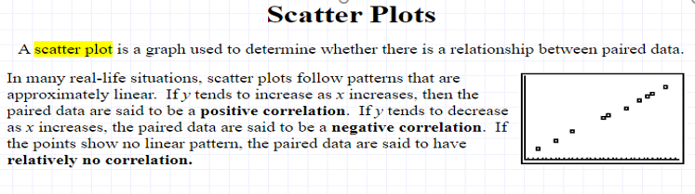
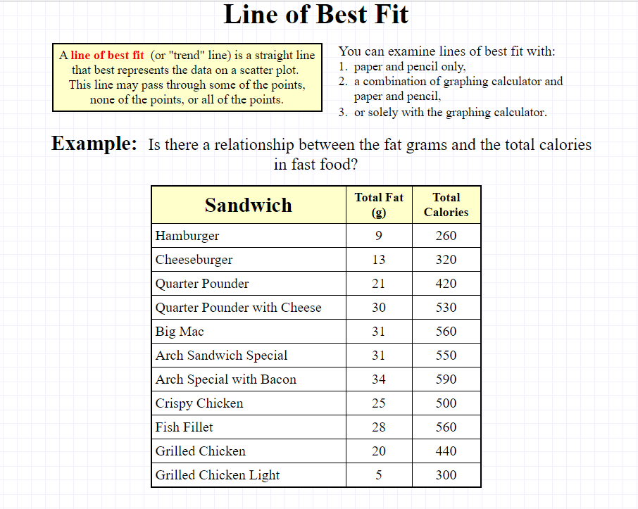
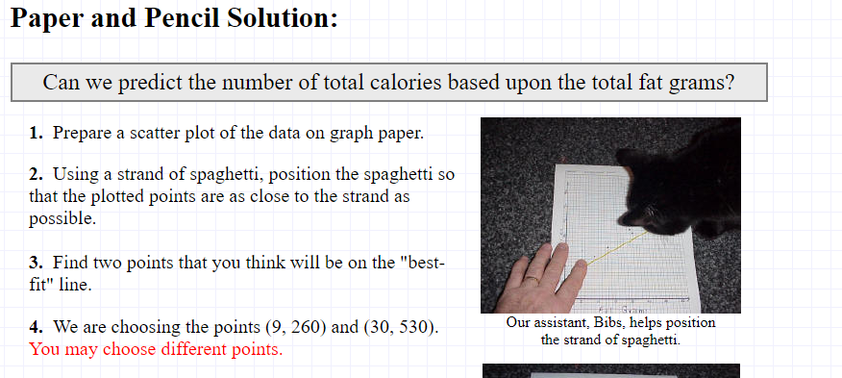 | 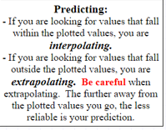
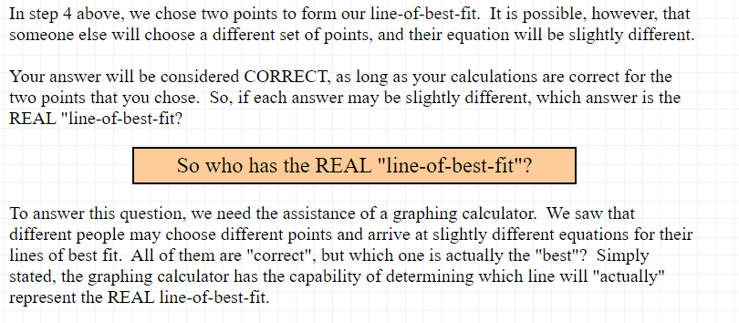
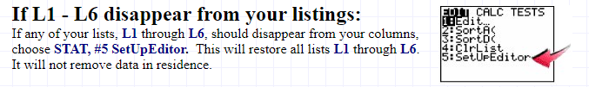
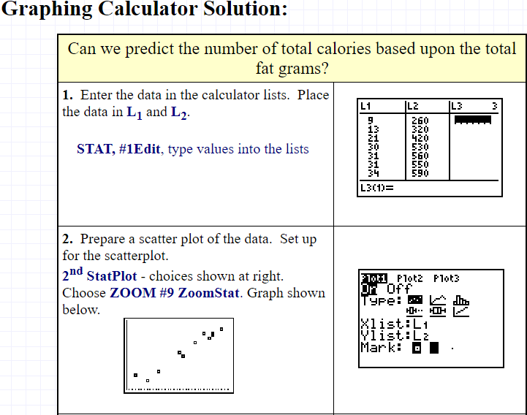 |  |  | 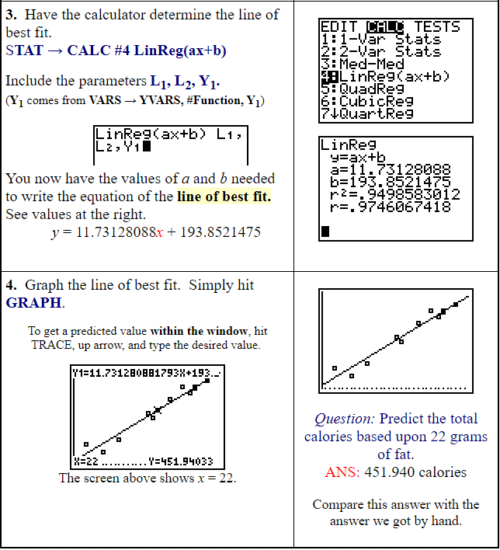
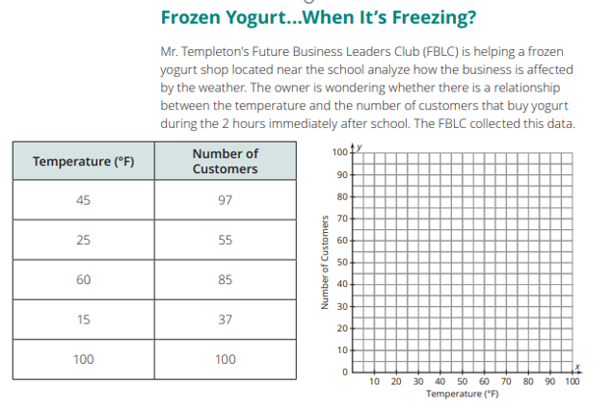 |  | 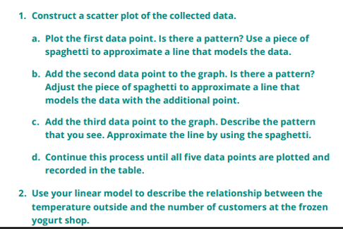
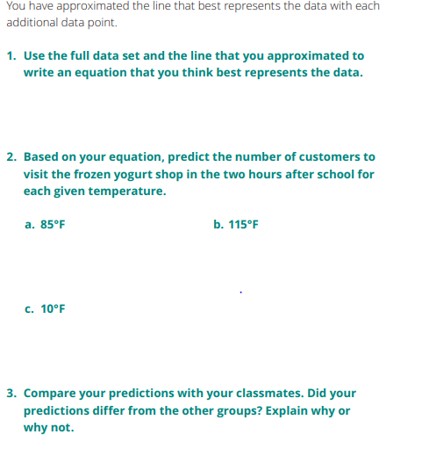
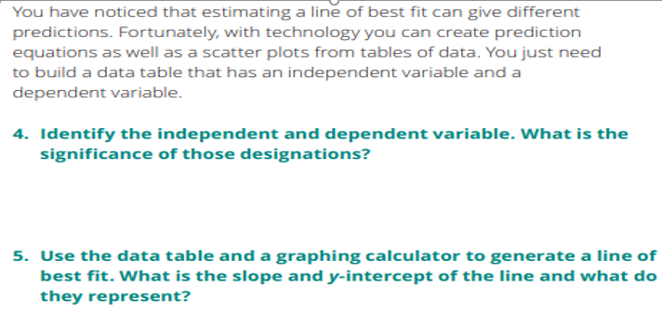 | 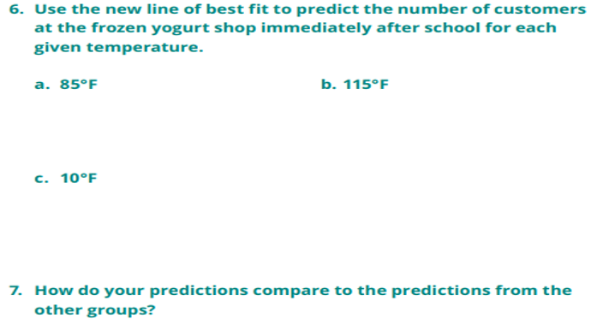
Summary: The line of best fit can be used to model data and predict the dependent value when given the independent value.
Wrap-Up: Complete Practice #1 and #2 as Exit Ticket (We will go over for bell work on Day 2 of Lesson)
DAY TWO: Activity 1.2 “Making Predictions” p. m1-169 in book
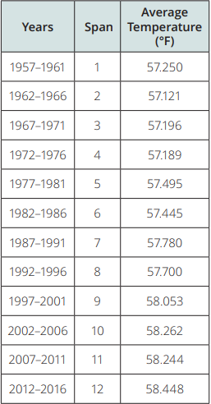 | The table shown lists the average global temperature in 5-year spans from 1957 to 2016.  - What is the range of the data set?  - Identify the independent and dependent quantities and their units of measure.  - Do the data itself represent a function? Does it appear that there is a specific function that could model this data set? If so, describe the function. If not, state why not.  - Use technology to graph a scatter plot demonstrating the relationship between time spans and temperature. What association do you notice?
#6- Remember, in calculator to use: Stat Edit, Stat Calc #4 to get Linear Regression Equation!!!
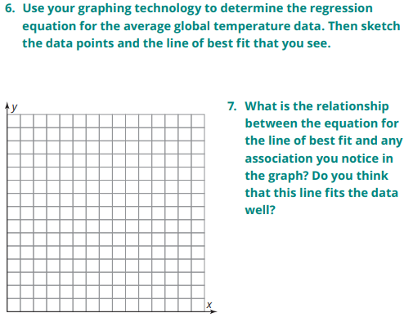 | 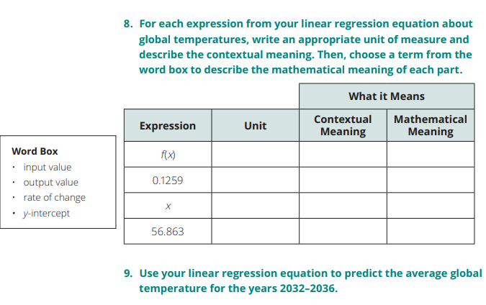

Practice:
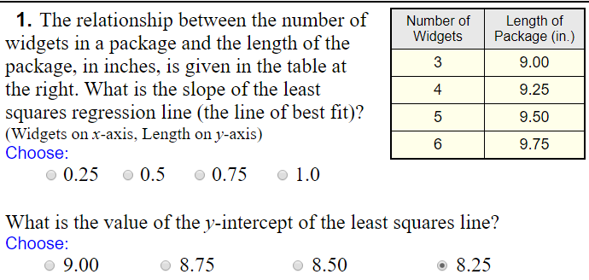 | 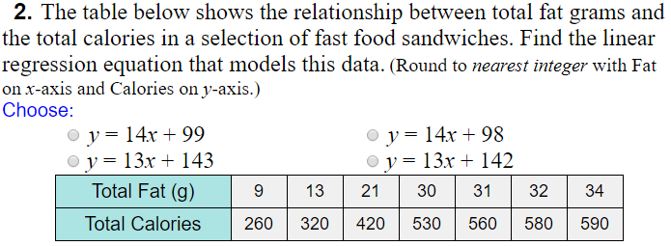
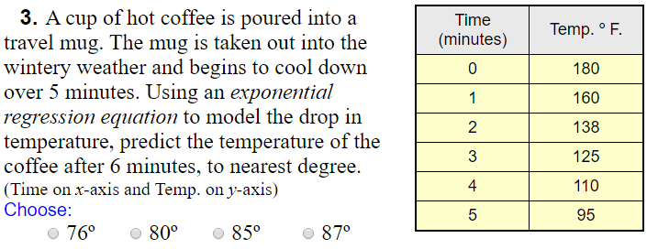 | 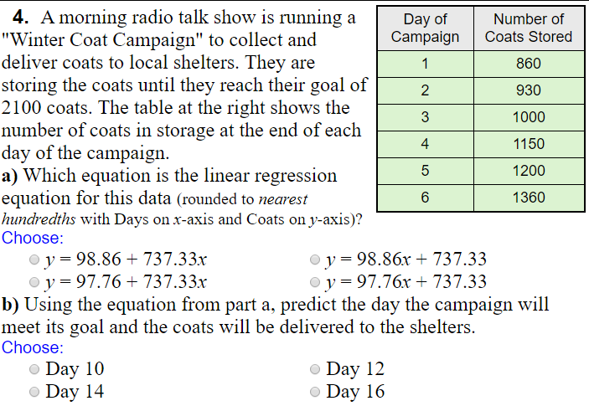

Making Predictions Within and Outside a Data Set” p. M1-171 in book
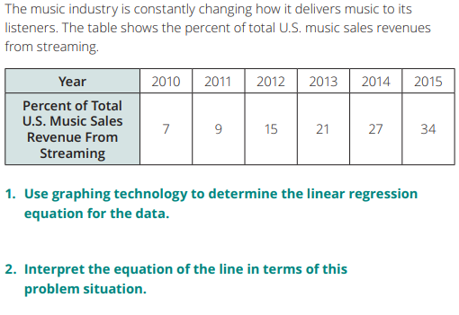 | 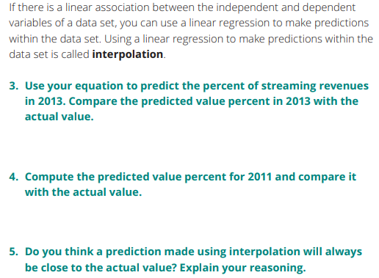
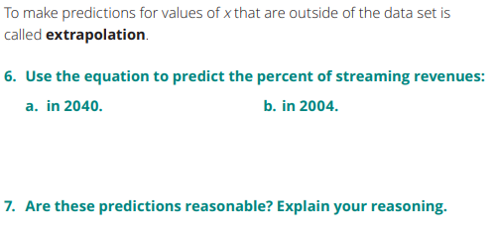 | 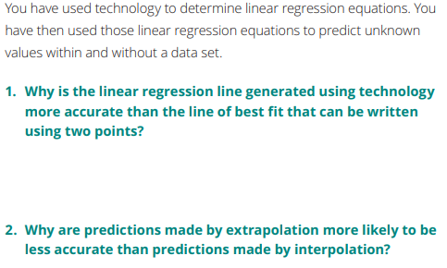

SPIRAL REVIEW:
- 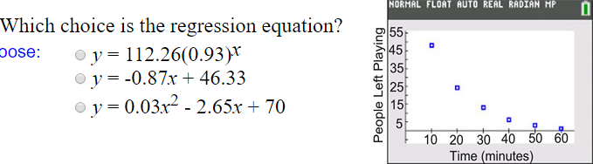 | - 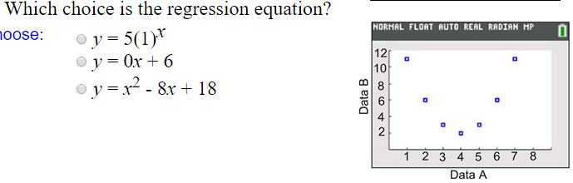
- 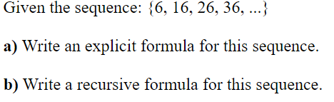 | - 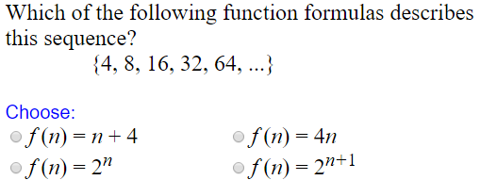
- 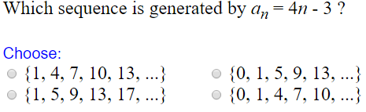 | - 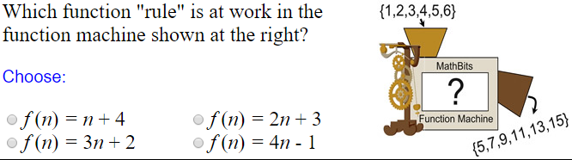

Homework: P. M1_173-174 (Write, Practice #1, Review #1-2)

