Linear Regression Practice Name______________________________ Period ___________
1. | The heights and weights of Coach Gagolewski’s baseball team are listed below:  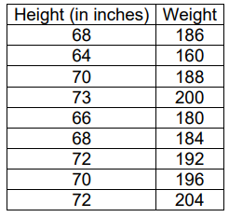  - Create a scatter plot of the data above.  - What is the equation of the line of best fit? (round values to the nearest integer)  - What is the approximate weight of a new player who is 74 inches tall?
2. | Mrs. Rudick compared the number of homework assignments her students completed with their test scores. The data is recorded in the table below. Fifteen homework assignments were assigned for this unit.  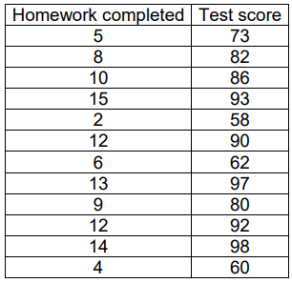  - Write the equation of the line of best fit, rounding values to the nearest hundredth.  - What score would a student who completed 7 homework assignments be expected to receive on the next test?  - Approximately how many homework assignments did a student complete who received an 88 on the test?  - Create a scatter plot of the data.
3. | 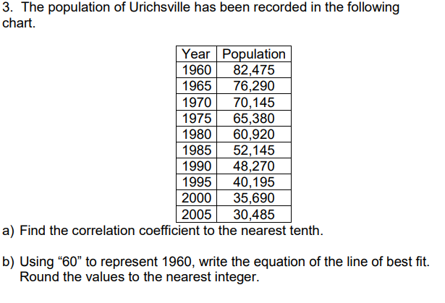  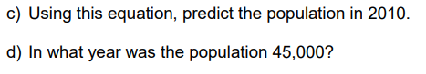
4. | 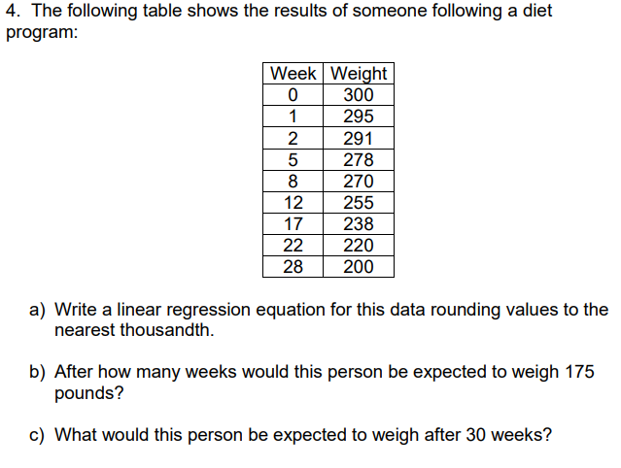
5. | 